

**NAME OF THE PROJECT**

**MICRO-CREDIT DEFAULTER**

**Submitted by:**

**AKANKSHA MISHRA**

**FLIPROBO SME:**

**MS. KHUSHBOO GaRG**

## ACKNOWLEDGMENT

I would like to express my special gratitude to “Flip Robo” team, who has given me this opportunity to deal with a beautiful dataset and it has helped me to improve my analyzation skills. And I want to express my huge gratitude to Ms. Khushboo Garg (SME Flip Robo), she is the person who has helped me to get out of all the difficulties I faced while doing the project.

A huge thanks to “Data trained” who are the reason behind my Internship at Fliprobo. Last but not least my parents who have been my backbone in every step of my life.

References use in this project:

1. SCIKIT Learn Library Documentation
2. Blogs from towardsdatascience, Analytics Vidya, Medium
3. Andrew Ng Notes on Machine Learning (GitHub)
4. Data Science Projects with Python Second Edition by Packt
5. Hands on Machine learning with scikit learn and tensor flow by Aurelien Geron
6. Stackoverflow.com to resolve some project related queries.
7. Predicting Credit Default among Micro Borrowers in Ghana Kwame Simpe Ofori, Eli Fianu
8. Predicting Microfinance Credit Default: A Study of Nsoatreman Rural Bank, Ghana Ernest Yeboah Boateng
9. A Machine Learning Approach for Micro-Credit Scoring Apostolos Ampountolas

And also thank you for many other persons who has helped me directly or indirectly to complete the project.

# Chap 1. Introduction

## Business Problem Framing

A Microfinance Institution (MFI) is an organization that offers financial services to low-income populations. MFS becomes very useful when targeting especially the unbanked poor families living in remote areas with not much sources of income. The Microfinance services (MFS) provided by MFI are Group Loans, Agricultural Loans, Individual Business Loans and so on.

Many microfinance institutions (MFI), experts and donors are supporting the idea of using mobile financial services (MFS) which they feel are more convenient and efficient, and cost saving, than the traditional high- touch model used since long for the purpose of delivering microfinance services. Though, the MFI industry is primarily focusing on low-income families and are very useful in such areas, the implementation of MFS has been uneven with both significant challenges and successes.

Today, microfinance is widely accepted as a poverty-reduction tool, representing $70 billion in outstanding loans and a global outreach of 200 million clients.

We are working with one such client that is in Telecom Industry. They are a fixed wireless telecommunications network provider. They have launched various products and have developed its business and organization based on the budget operator model, offering better products at Lower Prices to all value conscious customers through a strategy of disruptive innovation that focuses on the subscriber.

## Conceptual Background of the Domain Problem

Telecom Industries understand the importance of communication and how it affects a person’s life, thus, focusing on providing their services and products to low-income families and poor customers that can help them in the need of hour.

They are collaborating with an MFI to provide micro-credit on mobile balances to be paid back in 5 days. The Consumer is believed to be

defaulter if he deviates from the path of paying back the loaned amount within the time duration of 5 days. For the loan amount of 5 (in Indonesian Rupiah), payback amount should be 6 (in Indonesian Rupiah), while, for the loan amount of 10 (in Indonesian Rupiah), the payback amount should be 12 (in Indonesian Rupiah).

The sample data is provided to us from our client database. It is hereby given to you for this exercise. In order to improve the selection of customers for the credit, the client wants some predictions that could help them in further investment and improvement in selection of customers.

We have to build a model which can be used to predict in terms of a probability for each loan transaction, whether the customer will be paying back the loaned amount within 5 days of insurance of loan. In this case, Label ‘1’ indicates that the loan has been paid i.e., non-defaulter, while, Label ‘0’ indicates that the loan has not been paid i.e., defaulter.

## Review of Literature

### What is Microfinance?

“Microfinance” is often seen as financial services for poor and low- income clients (Ayayi, 2012; Mensah, 2013; Tang, 2002). In practice, the term is often used more narrowly to refer to loans and other services from providers that identify themselves as “microfinance institutions” (MFIs) [Consultative Group to Assist the Poor (CGAP) 2010]. Microfinance can also be described as a setup of a number of different operators focusing on the financially under-served people with the aim of satisfying their need for poverty alleviation, social promotion, emancipation, and inclusion. Microfinance institutions reach and serve their target market in very innovative ways (Milana 2012).

The CGAP (2010) identifies some unique features of microfinance as follows:

* + - Delivery of very small loans to unsalaried workers
    - Little or no collateral requirements
    - Group lending and liability
    - Pre-loan savings requirement
    - Gradually increasing loan sizes

Implicit guarantee of ready access to future loans if present loans are repaid fully and promptly Microfinance is seen as a catalyst for poverty alleviation, delivered in innovative and sustainable ways to assist the underserved poor, especially in developing countries (Dixon, Ritchie, & Siwale, 2007; Spiegel, 2012). Economic development may be achieved by helping the underserved poor to engage in income-generating/poverty reduction activities through entrepreneurship (Milana 2012). On December 18, 1997, the United Nations (UN) passed a microcredit resolution, also known as the Grameen Dialogue of 1998 at its General Assembly. The resolution was adopted because of the importance of microcredit programs in poverty reduction (Elahi & Demopoulos 2004). The UN later declared the year 2005 as International Year of Micro Credit. Globally, Microfinance has become an important sector. It is estimated that more than 3,500 institutions are meeting the demands of 205 million clients with a volume that is still uncertain but substantial (Maes and Reed 2012).

### Default in Microfinance

Default in microfinance is the failure of a client to repay a loan. The default could be in terms of the amount to be paid or the timing of the payment. MFIs can sustain and increase deployment of loans to stimulate the poverty reduction goal if repayment rates are high and consistent (Wongnaa 2013).

### Machine Learning Techniques for microfinance & finance

Pollio and Obuobie [ ] applied logistic regression on four factors and concluded that the probability of default increases with the number of dependents, whether the proceeds are used to acquire fixed assets, the frequency of monitoring, decreases with the availability of non-business income, years in business, the number of guarantors, whether the proceeds were used for working capital purposes and whether the client is a first-time borrower.

In Addo et al. (2018) the authors examined credit risk scoring by employing various machine and deep learning techniques. The authors

used binary classifiers in modelling loan default probability (DP) estimations by incorporating ten key features to test the classifiers’ stability by evaluating performance on separate data. Their results indicated that the models such as the logistic regression, random forest, and gradient boosting modelling generated more accurate results than the models based on the neural network approach incorporating various technicalities.

Machine learning-based systems are growing in popularity in research applications in most disciplines. Considerable decision-making knowledge from data has been acquired in the broad area of machine learning, in which decision-making tree-based ensemble techniques are recognized for supervised classification problems. Classification is an essential form of data analysis in data mining that formulates models while describing significant data classes (Rastogi and Shim 2000). Accordingly, such models estimate categorical class labels, which can provide users with an enhanced understanding of the data at large Han et al. (2012) resulted in significant advancements in classification accuracy.

## Motivation for the Problem Undertaken

The project was the first provided to me by Flip Robo Technologies as a part of the internship programme. The exposure to real world data and the opportunity to deploy my skillset in solving a real time problem has been the primary motivation.

This project includes the real time problem for Microfinance Institution (MFI), and it is related to financial sectors, as I believe that with growing technologies and Idea can make a difference, there are so much in the financial market to explore and analyse and with Data Science the financial world becomes more interesting. The objective of the project is to prepare a model based on the sample dataset that classifies all loan defaulters and help our client in further investment and improvement in selection of customers. The model will be a good way for the management to understand whether the customer will be paying back the loaned amount within 5 days of insurance of loan.

# Chap 2 Analytical Problem Framing

## 1. Mathematical / Analytical Modelling of the Problem

Whenever we employ any ML algorithm, statistical models or feature pre-processing in background lot of mathematical framework work. In this project we have done lot of data pre-processing & ML model building. In this section we dive into mathematical background of some of these algorithms.

1. Logistic Regression

The response variable, label, is a binary variable (whether the loan was repaid or not). Therefore, the logistic regression is a suitable technique to use because it is developed to predict a binary dependent variable as a function of the predictor variables. The logit, in this model, is the likelihood ratio that the dependent variable, non-defaulter, is one (1) as opposed to zero (0), defaulter. The probability, P, of credit default is given by;

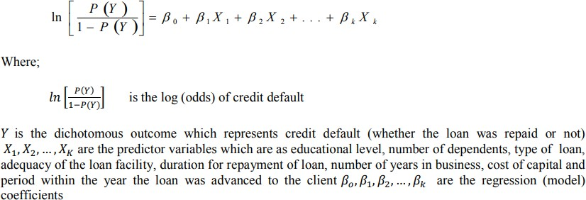

1. Decision Tree Classifier

Decision Trees (DTs) are a non-parametric (fixed number of parameters) supervised learning method used for classification and regression. The goal is to create a model that predicts the label of a target variable by learning simple decision rules inferred from the data features.

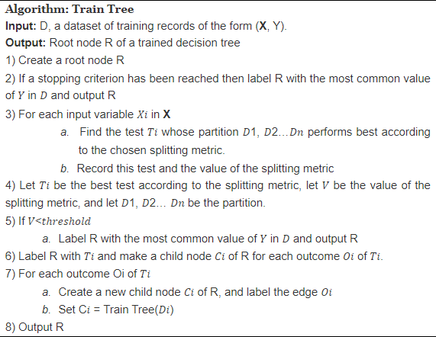

The application to decision trees arises from the fact that at each node, when considering a split on a given attribute, we have a probability distribution 𝑃 with a component 𝑝𝑗 for each class 𝑗 of the target variable

𝑌. Hence, we see that a split on an attribute it most impure if 𝑃 is uniform, and is pure if some 𝑝𝑗=1, meaning all records that past this split are definitely of class 𝑗. Once we have an impurity function, we can define an impurity measure of a dataset D node 𝑛 as so. If there are 𝑘 possible values 𝑦1, 𝑦2, …, 𝑦𝑘 of the target variable 𝑌, and 𝜎 is the selection operator from relational algebra then the probability distribution of 𝑆 over the attribute 𝑌 is

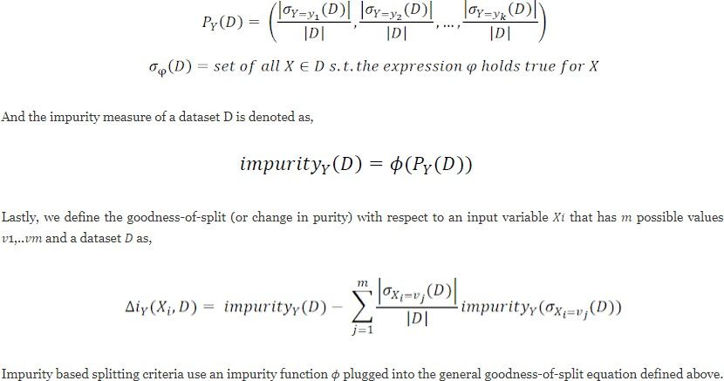

Information gain is a splitting criterion that comes from information theory. It uses information entropy as the impurity function Given a probability distribution 𝑃= (𝑝1, 𝑝2...𝑝𝑛), where 𝑝𝑖 is the probability that a point is in the subset 𝐷𝑖 of a dataset 𝐷, we define the entropy 𝐻:

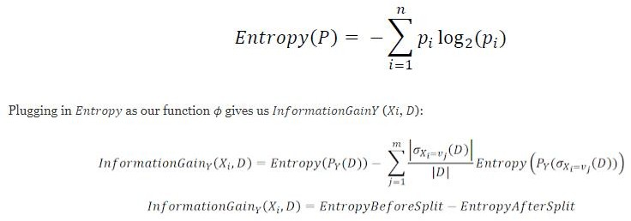

1. Random Forest Classifier

The random forest classifier is an ensemble method algorithm of decision trees wherein each tree depends on randomly selected samples trained independently, with a similar distribution for all the trees in the forest. Hence, a random forest is a classifier incorporating a collection of tree-structured classifiers that decrease overfitting, resulting in an increase in the overall accuracy (Geurts et al. 2006). As such, random forest’s accuracy differs based on the strength of each tree classifier and their dependencies

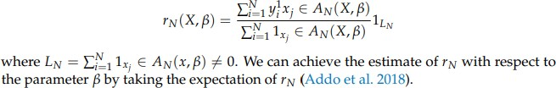

1. Extra Trees Classifier

The extremely randomized trees classifier (extra trees classifier) establishes an ensemble of decision trees following an original top-down approach. Thus, it is similar to a random forest classifier differing only in the decision trees’ mode of construction. Each decision tree is formed from the initial training data set sample. It entails random both element and cut-point choice while dividing a node of a tree. Hence, it differs from other tree-based ensemble approaches because it divides nodes by

determining cut-points entirely at random, and it practices on the entire training sample to grow the trees. The practice of using the entire initial training samples instead of bootstrap replicas is to decrease bias. At each test node, each extra trees algorithm is provided by the number of decision trees in the ensemble (denote by M), the number of features randomly selected at each node (K), and the minimum number of instances needed to split a node (nmin). Hence, each decision tree must choose the best feature to split the data based on some criteria, leading to the final prediction by forming multiple decision trees.

## Data Sources and their formats

The data set comes from my internship company – Fliprobo technologies in excel format.

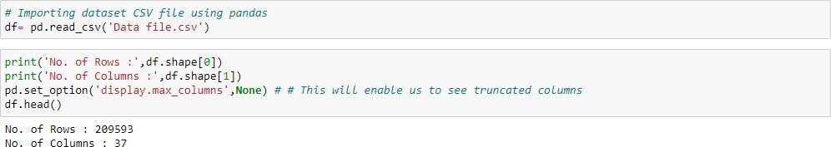

There are 37 columns and 209593 rows in this dataset. The different features in dataset are as below:

* + - label : Flag indicating whether the user paid back the credit amount within 5 days of issuing the loan {1:success, 0:failure}
    - msisdn : mobile number of user
    - aon : age on cellular network in days
    - daily_decr30 : Daily amount spent from main account, averaged over last 30 days (in Indonesian Rupiah)
    - daily_decr90 : Daily amount spent from main account, averaged over last 90 days (in Indonesian Rupiah)
    - rental30 : Average main account balance over last 30 days
    - rental90 : Average main account balance over last 90 days
    - last_rech_date_ma : Number of days till last recharge of main account
    - last_rech_date_da: Number of days till last recharge of data account
    - last_rech_amt_ma : Amount of last recharge of main account (in Indonesian Rupiah)
    - cnt_ma_rech30 : Number of times main account got recharged in last 30 days
    - fr_ma_rech30 : Frequency of main account recharged in last 30 days
    - sumamnt_ma_rech30 : Total amount of recharge in main account over last 30 days (in Indonesian Rupiah)
    - medianamnt_ma_rech30 : Median of amount of recharges done in main account over last 30 days at user level (in Indonesian Rupiah)
    - medianmarechprebal30 : Median of main account balance just before recharge in last 30 days at user level (in Indonesian Rupiah)
    - cnt_ma_rech90 : Number of times main account got recharged in last 90 days
    - fr_ma_rech90 : Frequency of main account recharged in last 90 days
    - sumamnt_ma_rech90: Total amount of recharge in main account over last 90 days (in Indonesian Rupiah)
    - medianamnt_ma_rech90: Median of amount of recharges done in main account over last 90 days at user level (in Indonesian Rupiah)
    - medianmarechprebal90: Median of main account balance just before recharge in last 90 days at user level (in Indonesian Rupiah)
    - cnt_da_rech30 : Number of times data account got recharged in last 30 days
    - fr_da_rech30: Frequency of data account recharged in last 30 days
    - cnt_da_rech90 : Number of times data account got recharged in last 90 days
    - fr_da_rech90 : Frequency of data account recharged in last 90 days
    - cnt_loans30 : Number of loans taken by user in last 30 days
    - amnt_loans30 : Total amount of loans taken by user in last 30 days
    - maxamnt_loans30 : maximum amount of loan taken by the user in last 30 days
    - medianamnt_loans30 : Median of amounts of loan taken by the user in last 30 days
    - cnt_loans90 : Number of loans taken by user in last 90 days
    - amnt_loans90 : Total amount of loans taken by user in last 90 days
    - maxamnt_loans90 : maximum amount of loan taken by the user in last 90 days
    - medianamnt_loans90 : Median of amounts of loan taken by the user in last 90 days
    - payback30: Average payback time in days over last 30 days
    - payback90: Average payback time in days over last 90 days
    - pcircle: telecom circle
    - pdate: date

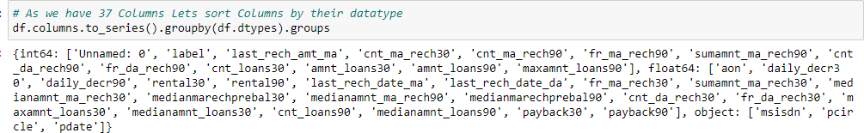

The different datatypes of these features are as shown in above figure. Out of all features only three features with object datatypes and rest are int64. We can note here ‘pdate’ has datatype of object instead of datetime datatype.

1. Data Pre-processing

The dataset is large and it may contain some data error. In order to reach clean, error free data some pre-processing is done on data. At first integrity check is perform on data for presence of missing values,

whitespaces. After that statistical matrix is plotted using df.describe() command to gain more insight about data.

* Missing value check – Data contain no missing value
* Data integrity check –

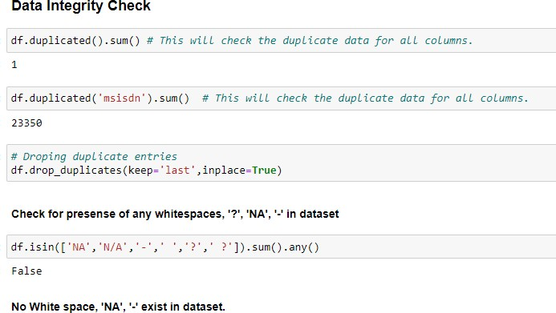

* Statistical Matrix –

From df.describe () command we got some key observation about data. One of it was that some features contain negative values and another observation few features contain extreme maximum value indicating possible outliers or invalid data.

* Strategy to handle data error in min and max column -

Assumption- All negative values are typing error happen accidentally by type - in front of original value (except feature depicting median).

Corrective approach - Negative values are converted into absolute value to correct negative typing error whenever applicable except feature depicting median.

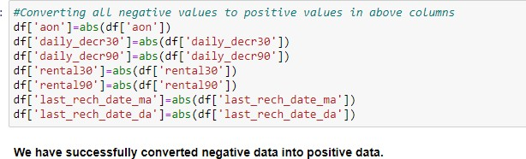

Upper limit of these features handles by outlier removal.

* Data error and correction in maxamnt_loans30 column

(maxamnt_loans30: maximum amount of loan taken by the user in last 30 days)

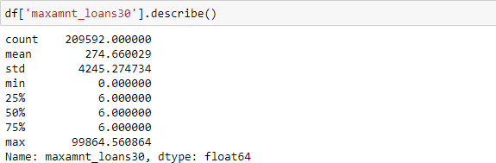

The maximum value in maxamnt_loans30 is not reliable. We already know maximum loan amount taken by customers can be 0,5,10 and which can be repay with amount of 0,6,12.

Assumption - The maximum value in maxamnt_loans30 is 12. We gone replace values greater than 12 into category of zero.

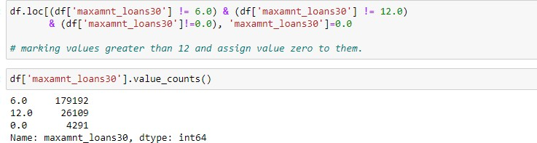

* Feature Engineering on 'pdate' column

Simple feature engineering operation perform on ‘pdate’ to extract day, month and year column. At last Unnamed :0, PCircle , msisdn columns are drop as they are unnecessary for further investigation

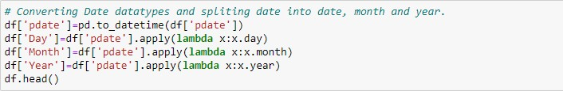

* Outliers Detection and removal –

Outliers detected in boxplot. In order to remove outliers Z-score method employ but it results in huge data loss of 23.42 %, which we cannot afford. We got observation from boxplot that outliers do not exist in lower bound but outliers exist in upper bound of features. Based on this observation we decided to employ quantile-based flooring- capping method. Flooring is performed at 0th percentile for lower bound and capping perform at 99th percentile for upper bound.

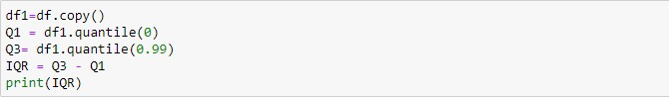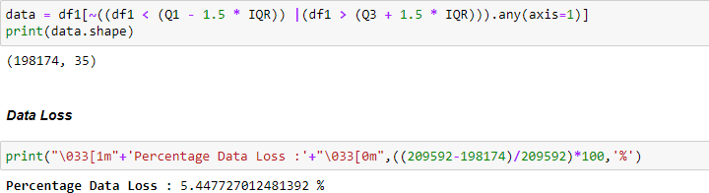

* Skewness in features & it’s transformation

Considerable amount of skewness found in most features by skew () function. Power transformer from sklearn.preprocessing library used to transform skewness in features.

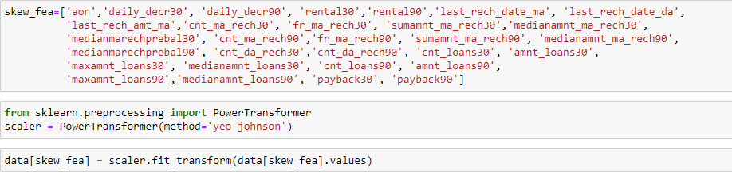

For most of feature’s skewness is reduce within permissible limit except

few ones.

1. Data Inputs- Logic- Output Relationships

To gain more insight about relationship between input & output heatmap of correlation and bar plot of correlation of label with independents features is plotted.

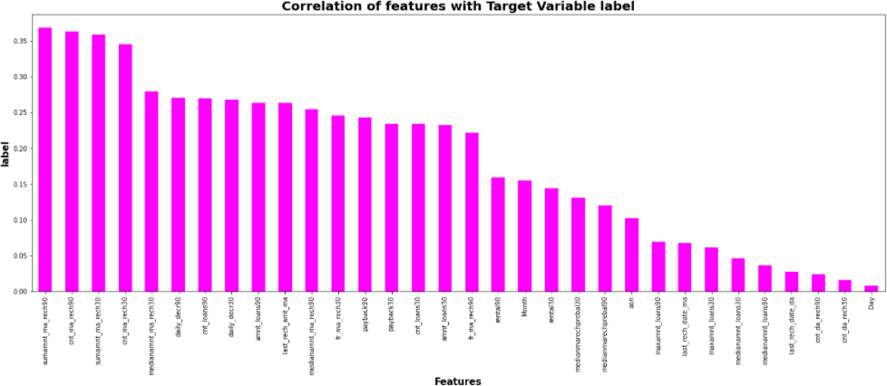

We can see that most of independent features are poorly or moderately correlated with target variable label. After that data is split into X and Y and data is scaled using standard scalar. The target variable label is imbalanced in nature, in order to resolved it SMOTE is applied to oversample minority label class.

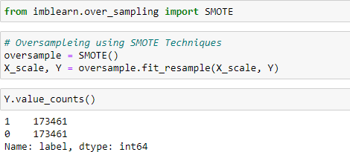

We have successfully resolved the class imbalanced problem and now all the categories have same data ensuring that the ML model does not get biased towards one category. The multicollinearity between features checked using variance inflation factor. Few findings are as below:

* + - daily_decr30 and daily_decr90 are highly correlated with each other.
    - cnt_loans90 and amnt_loans90 are highly correlated with each other.
    - cnt_loans30 and amnt_loans30 are highly correlated with each other.
    - cnt_ma_rech30 and sumamnt_ma_rech30 are highly correlated with each other.

For most Independent feature VIF is exceed permissible limit of 10. PCA is applied to remove multicollinearity among features.

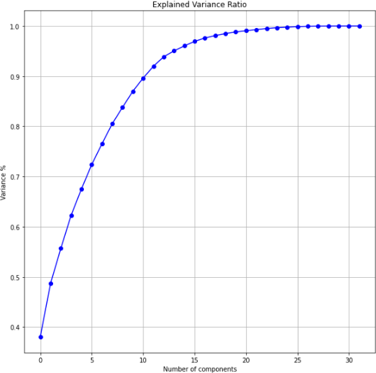

we can see that 11 principal components attribute for 90% of variation in the data. We shall pick the first 11 components for our prediction.

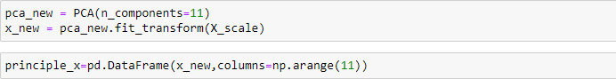

1. Hardware and Software Requirements and Tools Used Hardware Used -
2. Processor — Intel i3 processor with 2.4GHZ
3. RAM — 4 GB
4. GPU — 2GB AMD Radeon Graphics card Software utilised -
5. Anaconda – Jupyter Notebook
6. Google Colab – for Hyper parameter tuning Libraries Used –

Different libraries are used while building ML model and Visualisation of data.

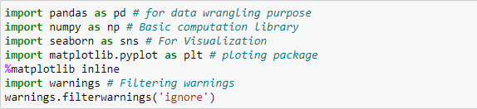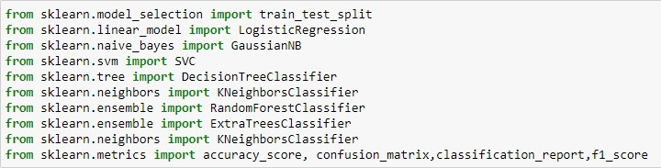

# Chap. 3 Models Development & Evaluation

## IDENTIFICATION OF POSSIBLE PROBLEM- SOLVING APPROACHES (METHODS)

The target variable label has two classes i.e., label ’1’ indicates non- defaulter & label ‘0’ indicates defaulter. Our objective is to predict whether customer is defaulter or not. This becomes binary classification problem which can be solved using various classification algorithms. In order to gain high accuracy of model we will train model with different classification model and select final model among them. To enhance performance of best model will employ hyper parameter tuning over it. At end we will save our final model using joblib.

## Testing of Identified Approaches (Algorithms)

The different classification algorithm used in this project to build ML model are as below:

* + Logistics Regression
  + Decision Tree Classifier
  + Random Forest Classifier
  + Extra Tree Classifier

## KEY METRICS FOR SUCCESS IN SOLVING PROBLEM UNDER CONSIDERATION

* Precision can be seen as a measure of quality; higher precision means that an algorithm returns more relevant results than irrelevant ones.
* Recall is used as a measure of quantity and high recall means that an algorithm returns most of the relevant results.
* Accuracy score is used when the True Positives and True negatives are more important. Accuracy can be used when the class distribution is similar.
* F1-score is used when the False Negatives and False Positives are crucial. While F1-score is a better metric when there are imbalanced classes.
* Cross validation Score: To run cross-validation on multiple metrics and also to return train scores, fit times and score times. Get predictions from each split of cross-validation for diagnostic purposes. Make a scorer from a performance metric or loss function.
* AUC_ROC _score: ROC curve. It is a plot of the false positive rate (x- axis) versus the true positive rate (y-axis) for a number of different candidate threshold values between 0.0 and 1.0
* We have used Accuracy Score and Cross validation score as key parameter for model evaluation in this project since balancing of data is perform.

## RUN AND EVALUATE SELECTED MODELS

### LOGISTICS REGRESSION

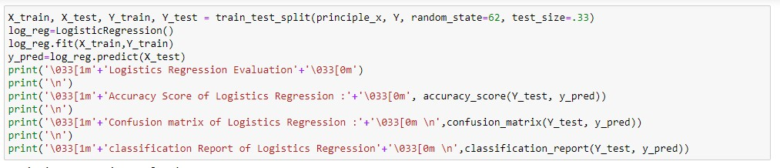

Model is train on Logistics Regression and evaluation matrix is as follow:

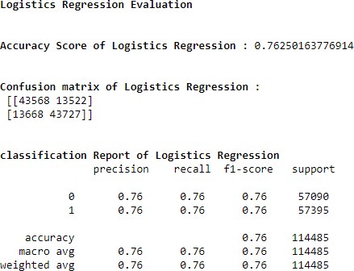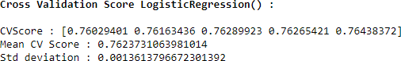

### DECISION TREE CLASSIFIER

Model is train on Decision Tree Classifier and evaluation matrix is as follow:

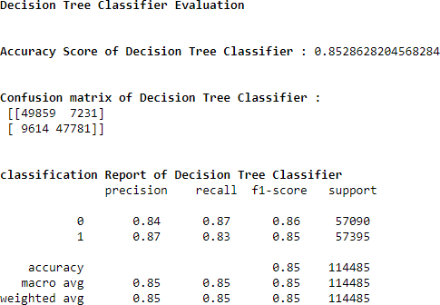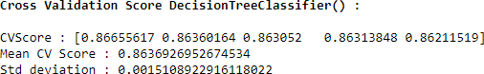

### RANDOM FOREST CLASSIFIER

Model is train on Random Forest Classifier and evaluation matrix is as follow:

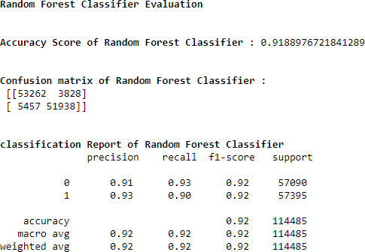

In all model k-5 fold cross validation is done.

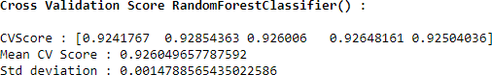

### EXTRA TREE CLASSIFIER

Model is train on Extra Tree Classifier and evaluation matrix is as follow:

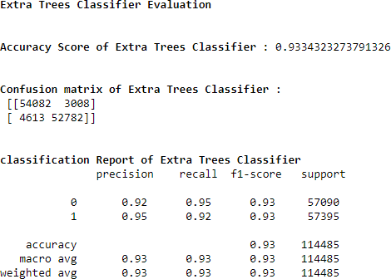

k-5 fold cross validation is perform

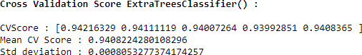

### AOC -ROC CURVE OF DIFFERENT ML MODELS

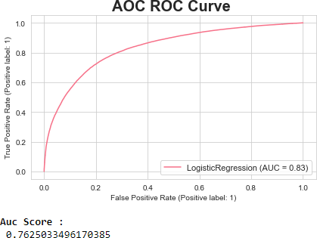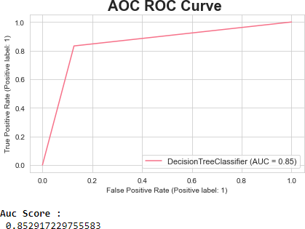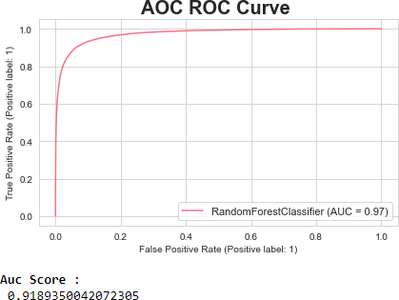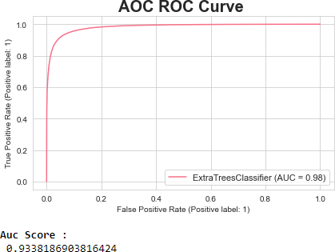

We can see Extra Tree Classifier gives maximum AUC. It also gives us highest accuracy score and cross validation score. Hyper parameter tuning perform on this model to enhance accuracy of model.

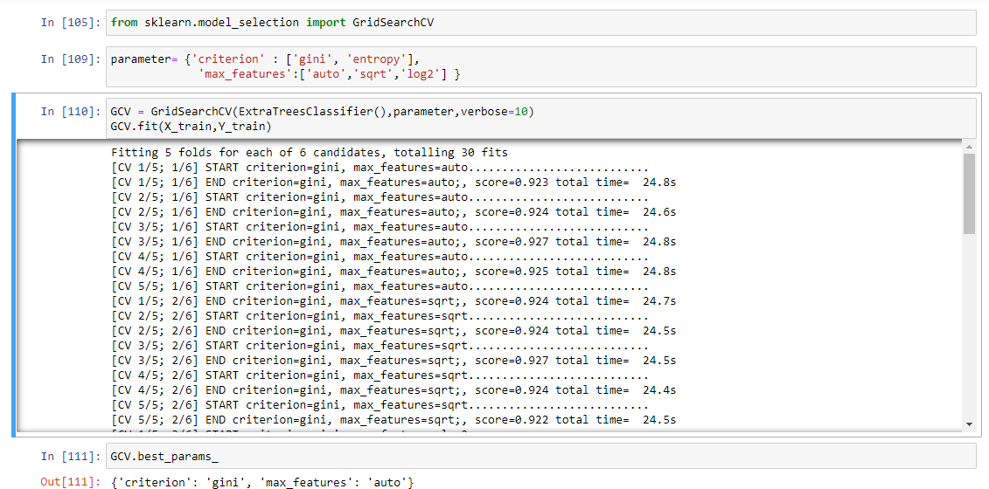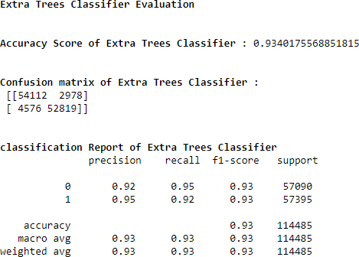

Hyper parameter tuning leads to sight increase in accuracy from 0.9434 to 0.9440. This will be over final model.

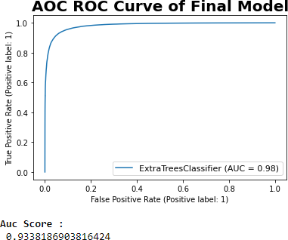

Final model is saved using joblib library.

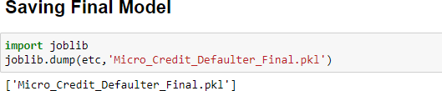

## VISUALIZATIONS

Lets see target variable distribution before balancing data

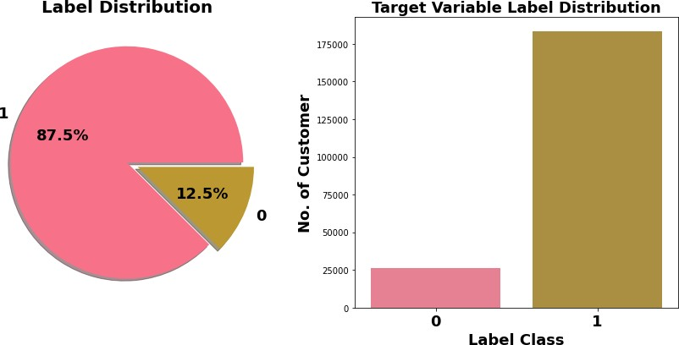

Here target variable Label class 1 represent non-defaulter while Label class 0 represent defaulter i.e., Loan not paid. We can see Most of customers are non-defaulter while very few are defaulter. From ML model building point of view target variable is imbalanced which need to balance using balancing techniques.

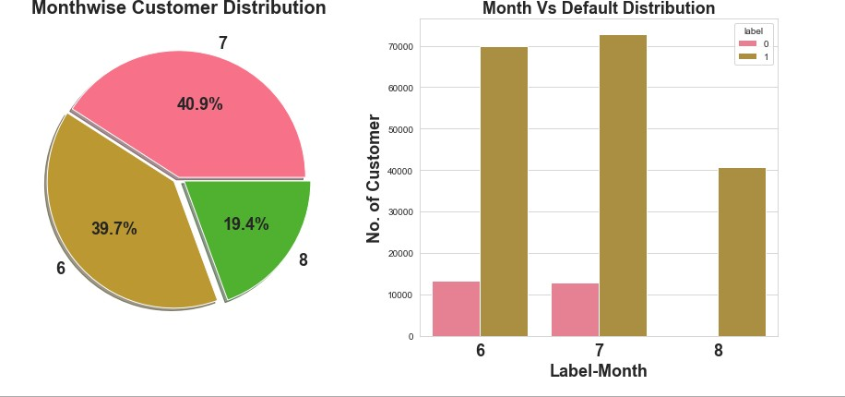

Most of data belong to month 6 and 7, followed my month 8. We can see very few defaulters in month 8.

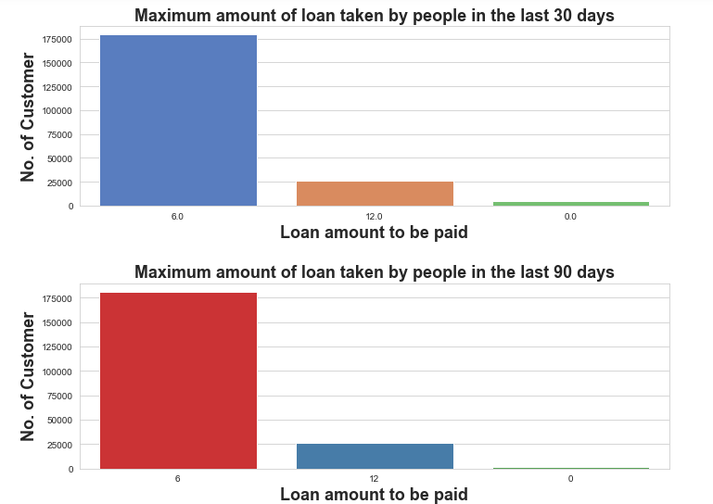

Observations:

1. In 30 days, maximum number of people had taken 6Rs as the loan amount and the number of people is 179192 whereas the number of people had not taken loan and their number is 4291.
2. In 90 days, maximum number of people had taken 6Rs as the loan amount and the number of people is 180944 whereas the number of people had not taken loan and their number is 2043.
3. Maximum number of people had taken 12Rs as the loan amount within 90 days and their number is 26605 whereas for 30 days the number of people who had taken 12Rs is 26109 respectively.

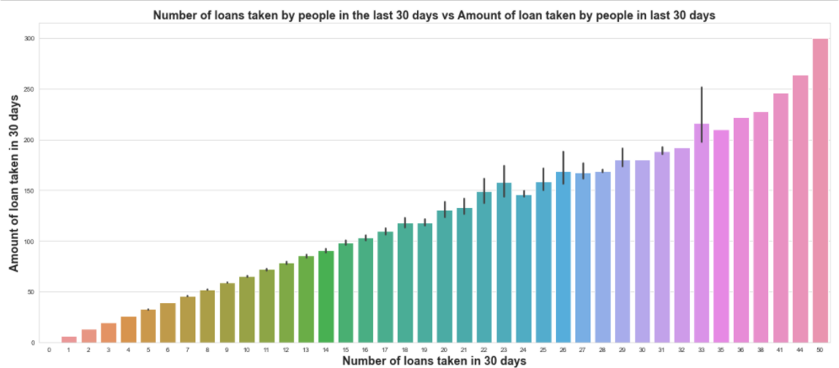

Maximum number of loans taken by the people is 50 and the Average loan amount is equivalent to 300. Minimum number of loans taken by the people is 0.

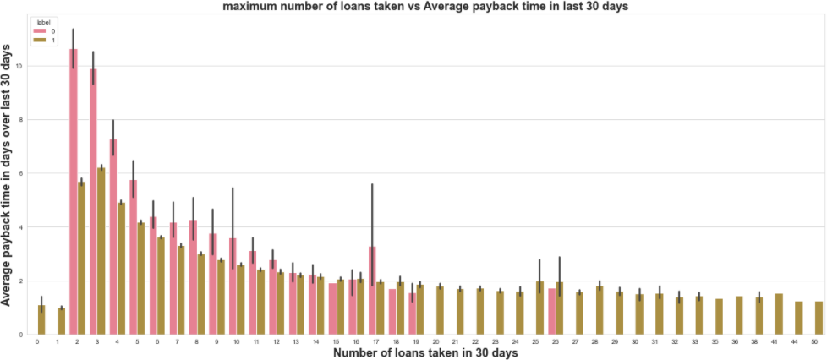

We can observe that the Average payback time over last 30 days is higher for people who had taken loan 2 times.

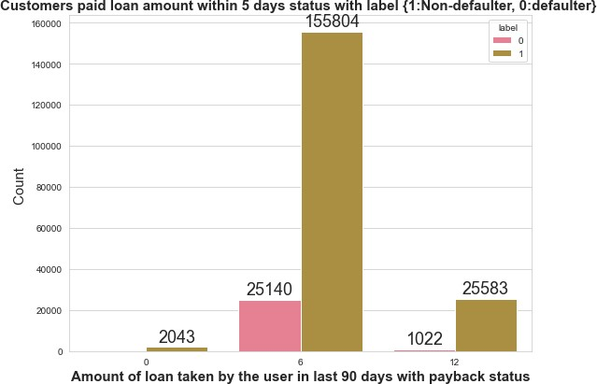

Very few defaulters in case of customers who have taken loan in amount of 12.

## 6. Interpretation of the Results

* As this dataset belongs from the year 2016, the data are recorded in the month of June, July and August. From the visualization, we can say that the most loan amount taken is rupiah 6 and most of the users are paying the loan within the time frame of 5 days, but many early users failed to do so. They usually take almost 7 to 8 days to pay the loan amount and even the valuable customers some time fails to pay the amount within the time frame.
* One more thing I noticed that, the smaller number of loans taken by the people are more defaulters and the frequently loan taking customers are less defaulters.
* Most importantly, the people are paying the amount early or lately and sometimes they might fail to pay within the time frame, but I observed that almost 80% of users are paying the amount within 7-8 days. It is recommended that to extent loan repayment time frame from 5 days to 7 days.
* The collected data is only for one Telecom circle area as per Dataset Documentation so that we had dropped that column.
* Customer who takes a greater number of loans are non-defaulters (i.e., 98% of the category) as they repay the loan within the given time i.e., 5 days

# Chap 4. Conclusion

## 1. Key Findings and Conclusions of the Study

|  |  |  |  |  |  |  |
| --- | --- | --- | --- | --- | --- | --- |
| Algorithm | Accuracy Score | Recall | Precision | F1 Score | CV Score | AUC  Score |
| Logistics Regression | 0.7625 | 0.76 | 0.76 | 0.76 | 0.7623 | 0.7625 |
| Decision Tree Classifier | 0.8528 | 0.85 | 0.85 | 0.85 | 0.8636 | 0.8529 |
| Random Forest Classifier | 0.9188 | 0.92 | 0.92 | 0.92 | 0.9260 | 0.9189 |
| Extra Tree Classifier (ETC) | 0.9334 | 0.93 | 0.93 | 0.93 | 0.9408 | 0.9338 |
| Final Model (ETC- Tuned) | 0.9345 | 0.93 | 0.93 | 0.93 | 0.9410 | 0.9338 |

1. Extra Tree Classifier Hyper parameter tuned gives maximum accuracy score of 0.9345 with cross validation score of 0.9410. It also gives us maximum AUC score.
2. 12.5 % customers are defaulters out of whole dataset.
3. Tendency to pay loan within 5 days is high among customer who take loan many times within month compare to those who take loan 1-2 times.
4. It is recommended that to extent loan repayment time frame from 5 days to 7 days.

## 2. Learning Outcomes of the Study in respect of Data Science

1. First time I handle such huge dataset.
2. First time any project I worked on ever need such data clean operation. I paid attention realistic & unrealistic data, considering it corrective measure taken as per need. This was beyond normal missing value imputation for me.
3. As data was huge require high computational capacity, it made me switch to Google Colab for running model and for hyperparameter Tuning. I Hyper Tuned Final model with Google Colab GPU.
4. I run Hyper parameter tuning 2-3 times with serval parameter. It was taking lot of times so at end I reduce Hyperparameter search parameter and still it was taken 6-7 hr for finding best parameter.

## 3. Limitations of this work and Scope for Future Work

1. Limited computational resources put limitation on optimization through hyper parameter tuning. Accuracy of model can increase with hyperparameter tuning with several different parameter. Here we use only two parameters for tuning.
2. Data is imbalanced, we utilised SMOTE for it but if get label data which at least in ratio of 70:30, It can give us much more realistic model.